null函数_矩阵的零空间

# null函数

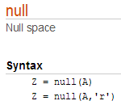

**Z = null(A)** is **an orthonormal basis** for *the null space* of A obtained from the singular value decomposition. That is, A*Z has negligible elements, size(Z,2) is the nullity of A, and Z'*Z = I.

**Z = null(A,'r')** is a "rational" basis for the null space obtained from the reduced row echelon form. A*Z is zero, size(Z,2) is an estimate for the nullity of A, and, if A is a small matrix with integer elements, the elements of the reduced row echelon form (as computed using rref) are ratios of small integers.

**The orthonormal basis** is preferable numerically, while the rational basis may be preferable pedagogically.